**SQL Capstone Project Documentation**

**Hospital Management Analysis**

**Abstract**

**INTRODUCTION**

This project analyzes how the hospital is performing both financially and operationally through key metrics such as revenue, treatment costs, patient demographics, and payment methods. It compares different treatment types, gender-based billing trends, and monthly performance to identify areas of strength and opportunities for improvement. The goal is to help stakeholders understand the relationship between service delivery and financial outcomes, and to guide better decision-making in hospital management and patient care.

**OBJECTIVES**

To analyze the financial and operational performance of the hospital across various treatment types, payment methods, and patient demographics, and to identify high and low performing areas to guide strategic decisions that enhance service efficiency, revenue generation, and overall patient care.

**POTENTIAL QUESTIONS**

* What are the trends in bill payments across months?
* What is the average treatment cost per treatment type?
* Does gender influence average bill amount?
* Which payment method generated most payment?
* Is there a difference in billing between visit reasons (e.g., emergency vs consultation)?
* How frequently do patients of different genders attend specific treatments?

**DATA SOURCE**

The Hospital Management Dataset was gotten from Kaggle

**DATA DESCRIPTION**

**Patient Table**

patient_id -> Unique ID for each patient  
first_name -> Patient's first name  
last_name -> Patient's last name  
gender -> Gender (M/F)  
date_of_birth -> Date of birth  
contact_number -> Phone number  
address -> Address of the patient  
registration_date -> Date of first registration at the hospital  
insurance_provider -> Insurance company name  
insurance_number -> Policy number  
email -> Email address

**Doctors Table**

doctor_id -> Unique ID for each doctor  
first_name -> Doctor's first name  
last_name -> Doctor's last name  
specialization -> Medical field of expertise  
phone_number -> Contact number  
years_experience -> Total years of experience  
hospital_branch -> Branch of hospital where doctor is based  
email -> Official email address

**Appointments Table**

appointment_id -> Unique appointment ID  
patient_id -> ID of the patient  
doctor_id -> ID of the attending doctor  
appointment_date -> Date of the appointment  
appointment_time -> Time of the appointment  
reason_for_visit -> Purpose of visit (e.g., checkup)  
status -> Status (Scheduled, Completed, Cancelled)

**Treatment Table**

treatment_id -> Unique ID for each treatment  
appointment_id -> Associated appointment ID  
treatment_type -> Type of treatment (e.g., MRI, X-ray)  
description -> Notes or procedure details  
cost -> Cost of treatment  
treatment_date -> Date when treatment was given

**Billings Table**

bill_id -> Unique billing ID  
patient_id -> ID of the billed patient  
treatment_id -> ID of the related treatment  
bill_date -> Date of billing  
amount -> Total amount billed  
payment_method -> Mode of payment (Cash, Card, Insurance)  
payment_status -> Status of payment (Paid, Pending, Failed)

**DATA CLEANING AND TRANSFORMATION**

The hospital management dataset was first gotten from Kaggle after which a database called TDI CAPSTONE was created in SQL and the five datasets were imported into the database and then the following was done:

* Checking for duplicates

SQL query was used to check for duplicates, and none was found (see in appendix)

* Handling missing values

SQL query was used to check for blanks, and none was found (see in appendix)

* Joining all tables together

SQL query was used to join all the tables together (see in appendix)

**Statistical Analysis**

**KPI Cards**

Created a pivot table with average growth rate, profit margin, revenue and market cap, for average growth rate I highlighted the value and right clicked and selected number formats and used this custom formatting #,##0.00"%" and did same for average profit margin and for average revenue and market cap I used this $#,##0.00"M" custom formatting.

**Referencing KPI Cards with dashboard**

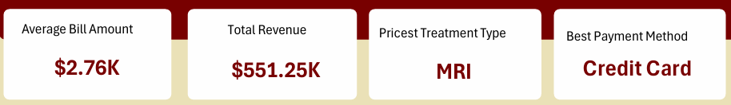

The kpi cards were created using shapes (rectangle: rounded corners) from the illustrations pane from the insert section on the tool bar after created one I duplicated to the amount I want by pressing down the CTRL button and dragging the shape until I have the amount I want and then I inserted a text box for title and the value and from the arrange section I aligned to top, distributed horizontally and grouped the kpi cards together.

For the values on the kpi cards I gave each kpi a specific name and I clicked on the text box and typed = and then I typed the name I gave to each cell and clicked ok.

**ANALYSIS**

* **Bill Payment Trend**

**Analysis Question:**

* What are the trends in bill payments across months?

**Approach to answering question**

After cleaning and joining the dataset in SQL the combined dataset was copied to a new excel workbook and was named combined dataset and I highlighted the entire dataset and created a pivot table with months from bill date in rows and BillAmount in values and set to sum and formatted BillAmount using this $#.0#,"K"custom number format and then I created a line chart by going to the pivot table analyze pane and clicking on pivot chart and selecting a line chart.

**Insights**

January and April have the highest bill payment while September and December have the least bill payment

* **Average Treatment Cost by Treatment Type**

**Analysis Question:**

* what is the average cost for each treatment type

**Approach to answering question**

After cleaning and joining the dataset in SQL the combined dataset was copied to a new excel workbook and was named combined dataset and I highlighted the entire dataset and created a pivot table with treatment type in rows and treatment cost in values and set to average and formatted treatment cost using this $#.0#,"K"custom number format and then I created a bar chart by going to the pivot table analyze pane and clicking on pivot chart and selecting a bar chart.

**Insights**

MRI and Physiotherapy have high treatment cost while ECG and Chemotherapy have the least treatment type.

* **Average Bill Amount by Gender**

**Analysis Question:**

* Does gender influence average bill amount?

**Approach to answering question**

After cleaning and joining the dataset in SQL the combined dataset was copied to a new excel workbook and was named combined dataset and I highlighted the entire dataset and created a pivot table with gender in rows and BillAmount in values and set to average and formatted BillAmount using this $#.0#,"K"custom number format and then I created a doughnut chart by going to the pivot table analyze pane and clicking on pivot chart and selecting a doughnut chart.

**Insight**

The average bill amount by gender shows males contributing $2.78K and females $2.71K. This shows that gender influences bill amount.

* **Payment Method by Bill Amount**

**Analysis Question:**

* Which Payment Method Generated Most Payment?

**Approach to answering question**

After cleaning and joining the dataset in SQL the combined dataset was copied to a new excel workbook and was named combined dataset and I highlighted the entire dataset and created a pivot table with payment method in rows and BillAmount in values and set to sum and formatted BillAmount using this $#.0#,"K"custom number format and then I created a pie chart by going to the pivot table analyze pane and clicking on pivot chart and selecting a pie chart.

**Insights**

Credit card payments contribute the most to bill amounts ($201.38K), followed by Insurance ($182.16K) and Cash ($167.71K).

* **Billing Amount by Visit Reasons**

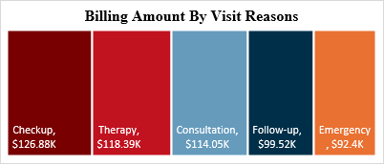

**Analysis Question:**

* Is there a difference in billing between visit reasons (e.g., emergency vs consultation)?

**Approach to answering question**

After cleaning and joining the dataset in SQL the combined dataset was copied to a new excel workbook and was named combined dataset and I highlighted the entire dataset and created a pivot table with reason for visit in rows and BillAmount in values and set to sum and formatted BillAmount using this $#.0#,"K"custom number format and then I copied the values out of the pivot table to another cell and used it to create a tree map chart by going to the pivot table analyze pane and clicking on pivot chart and selecting a tree map and this is because a tree map chart doesn’t work on pivot table.

**Insights**

The highest billing amount by visit reason is "Checkup" at $126.88K, followed by "Therapy" at $118.39K and "Consultation" at $114.05K while emergency is the least at $92.4k.

* **Treatment Types by Gender**

**Analysis Question:**

* How frequently do patients of different genders attend specific treatments?

**Approach to answering question**

After cleaning and joining the dataset in SQL the combined dataset was copied to a new excel workbook and was named combined dataset and I highlighted the entire dataset and created a pivot table with treatment type in rows, gender in column and appointment id in values and set to count and then I created a bar chart by going to the pivot table analyze pane and clicking on pivot chart and selecting a bar chart.

**Insights**

**For Males**

MRI is the most common treatment type (30 cases) followed by Chemotherapy 28 cases then ECG 27 cases, X-Ray is performed 23 cases and Physiotherapy is performed 22 cases.

**For Females**

Chemotherapy is the most common treatment type (21 cases) followed by Xray 18 cases then physiotherapy 14 cases, ECG 11 cases and MRI 6 cases.

**Visualization**

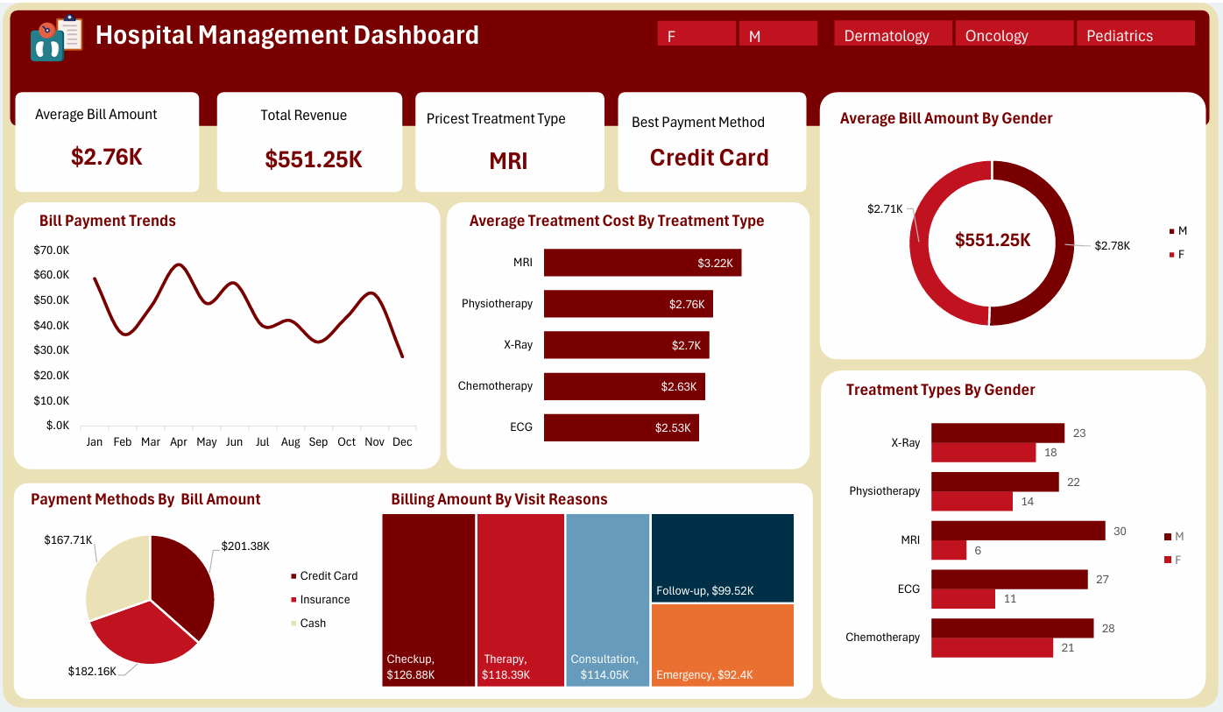

Below is the link to my dataset and dashboard:

<https://1drv.ms/x/c/0080c6f63596c3e2/Ecd4V_wStbZHlYHP60CqKYEBTFT6us2BewWwxY4WEoCZxQ?e=UxV2WL&nav=MTVfe0YzOUYwNjU4LTRBODItNEZBMi1BQkUzLTBERkQ1QjhBNkM5NH0>

**Interpretation of Results**

* The total revenue generated by the hospital is $551.25K, showing strong overall financial performance.
* The average bill amount is $2.76K, which means patients typically spend that much per treatment or visit.
* The most common and highest-earning visit reasons are Checkups ($126.88K), Therapy ($118.39K) and Consultation ($114.05K). These visit types bring in the most revenue for the hospital.
* Follow-ups and Emergency visits bring in less revenue, suggesting either lower volume or lower billing for those services.
* The best-performing payment method is Credit Card, contributing $201.38K to the revenue, followed by Insurance ($182.16K) and Cash ($167.71K). This indicates a strong preference for digital payments.
* When analyzing monthly bill payment trends, the hospital saw the highest number of bills in January and April, while September and December had fewer billings. This shows seasonal or fluctuating patient visits.
* In terms of treatment cost by type, MRI and Physiotherapy are the most expensive services on average, while ECG and Chemotherapy are less expensive.
* The average bill amount by gender shows variation males generally have higher treatment costs than females.
* Treatment types by gender shows that males across categories like MRI and Chemotherapy attend to their treatment unlike females.

**FILTERING DOWN BY** **SPECIALIZATION**

**Dermatology**

* the average bill amount is $2.9k.
* total revenue is $202.71k.
* the best payment method is credit card.
* The priciest treatment type is MRI.
* in terms of treatment cost by type MRI and x-ray are the most expensive.
* bill payment trend the department had the highest number of bills in July and October and less bill in May and December.
* Visiting for therapy and consultation bring more revenue.

**Oncology**

* the average bill amount is $2.8k.
* total revenue is $89.6k.
* the best payment method is credit card.
* The priciest treatment type is MRI.
* in terms of treatment cost by type MRI and physiotherapy are the most expensive.
* bill payment trend the department had the highest number of bills in January and May and less bill in September and December.
* Visiting for checkup and follow-up bring more revenue.

**Pediatrics**

* the average bill amount is $2.64k.
* total revenue is $258.94k.
* the best payment method is cash.
* The priciest treatment type is MRI.
* in terms of treatment cost by type MRI and chemotherapy are the most expensive.
* bill payment trend the department had the highest number of bills in April and June and less bill in July and December.
* visiting for checkup and consultation bring more revenue.

**FILTERING BY GENDER**

**Females**

* the average bill amount is $2.71k.
* total revenue is $190.05k.
* the best payment method is insurance.
* The priciest treatment type is MRI.
* in terms of treatment cost by type MRI and x-ray are the most expensive.
* bill payment trend females had the highest number of bills in January and March and less bill in October and December.
* visiting for checkup and therapy bring more revenue.

**Males**

* the average bill amount is $2.78k.
* total revenue is $361.2k.
* best payment method is credit card.
* The priciest treatment type is MRI.
* in terms of treatment cost by type MRI and physiotherapy are the most expensive.
* bill payment trend females had the highest number of bills in April and June and less bill in July and December.
* visiting for consultation and therapy brings more revenue.

**RECOMMENDATION**

* **Launch Seasonal Health Packages:** Offer bundled services (e.g., checkups + therapy) during slower months to boost patient volume and stabilize revenue.
* **Optimize MRI Usage & Pricing**: Introduce flexible MRI pricing options and review clinical necessity to manage costs and increase accessibility.
* **Promote Digital & Insurance Payments:** Encourage credit card and insurance use through partnerships and installment plans to improve cash flow and billing efficiency.
* **Run Gender-Based Campaigns:** Tailor outreach based on patient behavior—e.g., wellness campaigns for women, screening drives for men—to increase engagement.
* **Invest in High-Performing Departments:** Expand Pediatrics (highest revenue) and improve digital infrastructure in Dermatology and Oncology for greater efficiency.
* **Use Predictive Analytics:** Build a dashboard to forecast seasonal demand and monitor underperforming departments for proactive planning.
* **Boost Preventive Care in Low Seasons:** Offer discounted or incentive-based preventive services during slow months to maintain steady patient visits.

**CONCLUSION**

The hospital is generating strong revenue overall ($551.25K), with checkups, therapy, and consultations being the top revenue-driving visit types. MRI remains the priciest treatment heavily influencing bill amounts across all categories. Gender, specialization, and seasonality all impact billing trends and revenue. Digital payment (especially credit cards) is the preferred method, although cash still plays a major role in pediatrics. There are clear seasonal patterns in billing that can inform resource allocation and strategic planning. Male patients tend to incur higher treatment costs and generate more revenue, while different specializations perform unevenly.

**Appendix**

* Checking For Duplicates in The Patient Table

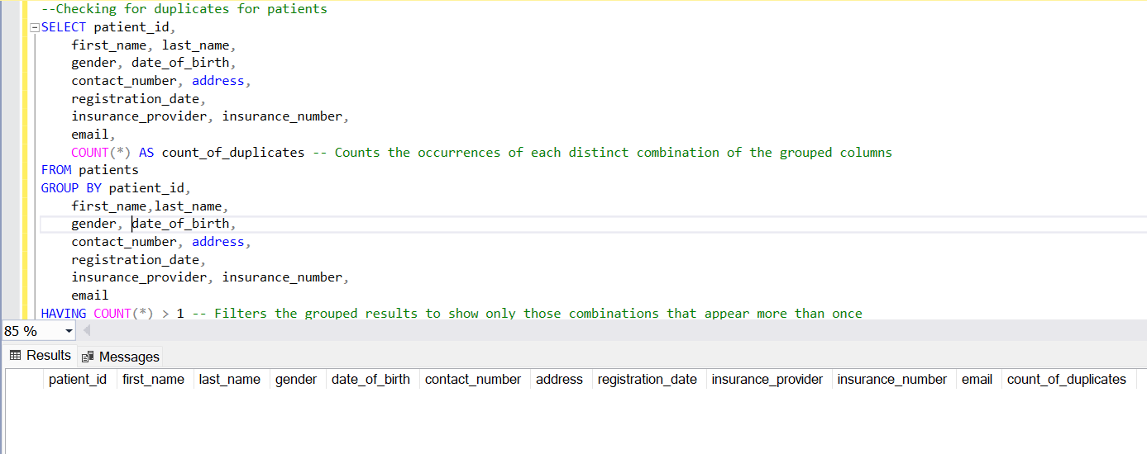

* Checking For Duplicates in The Treatment Table

* Checking For Duplicates in The Appointment Table

* Checking For Duplicates in The Billings Table

* Checking For Duplicates in The Doctors Table

* Checking For Blanks in The Patient Table

* Checking For Blanks in The Treatment Table

* Checking For Blanks in The Appointment Table

* Checking For Blanks in The Billing Table

* Checking for Blanks in the Doctors Table

* Combining All Tables Together

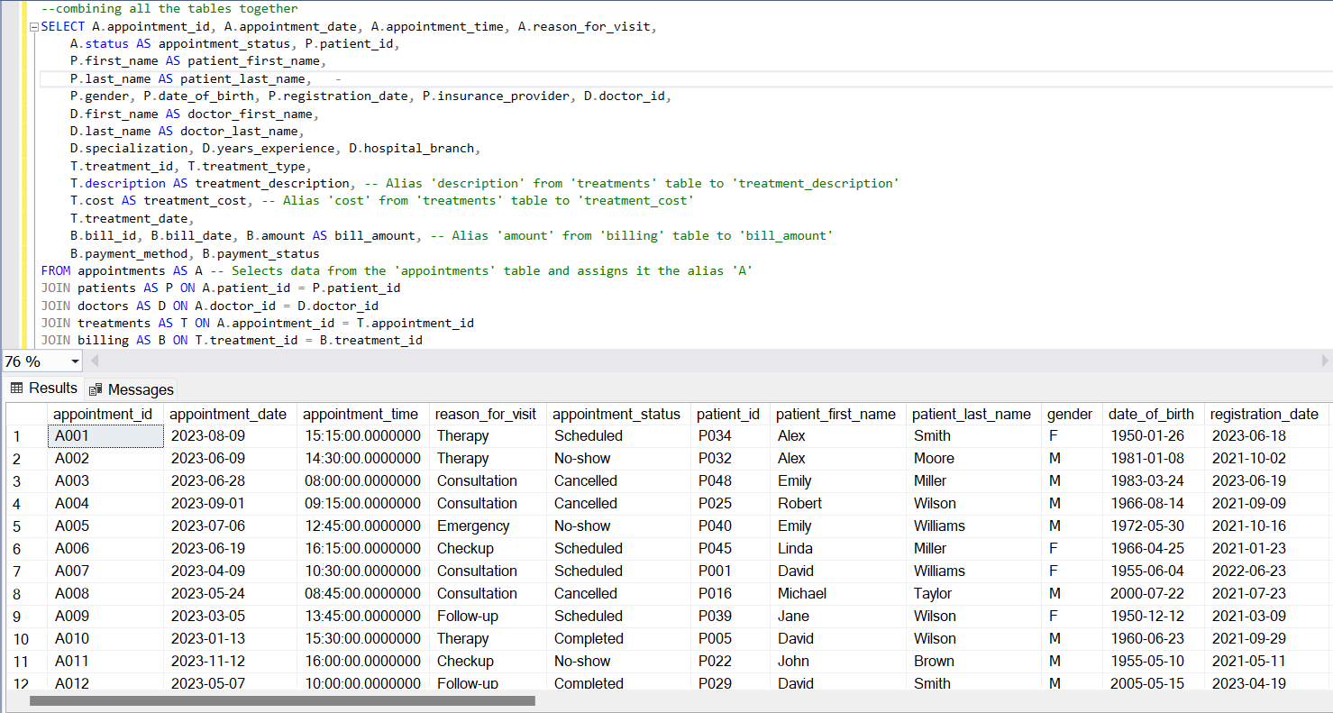

* What Are the Trends In bill Payment Across Months?

* What is The Average Cost for Each Type of Treatment

* Does Gender Influence Average Bill Amount?

* Which Payment Method Generated Most Payment?

* Is There a Difference in Billing Between Visit Reasons (e.g., Emergency vs Consultation)?

* How Frequently do Patients of Different Gender Attend Specific Treatment?

